User guide

# Installation

1: Download and extract project into a folder.

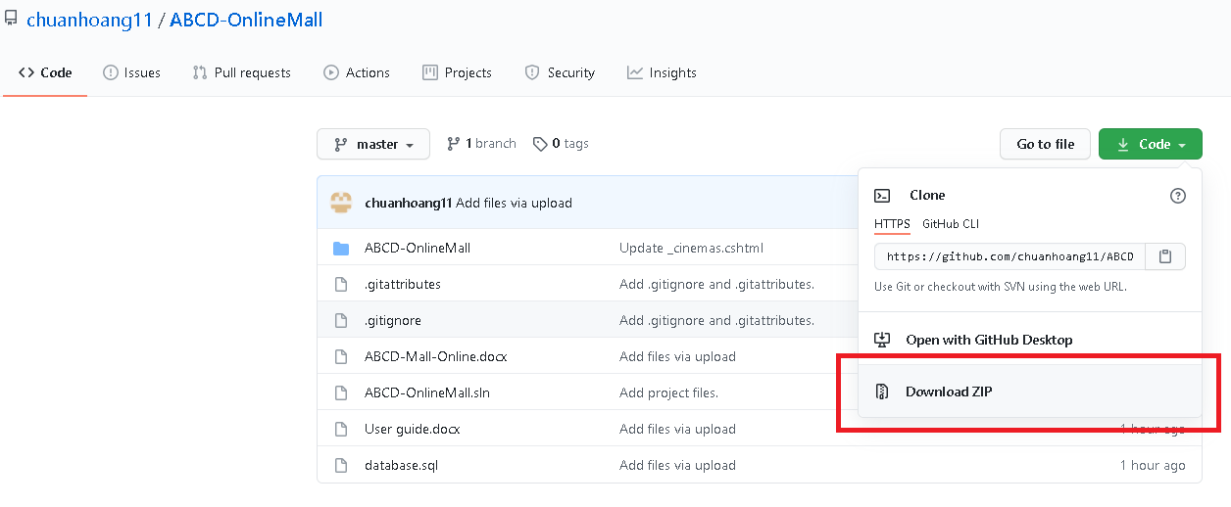

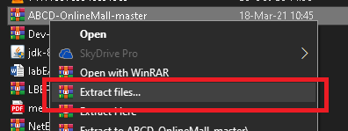  
Project link: <https://github.com/chuanhoang11/ABCD-OnlineMall>

2: Open Sql Server Management Studio, sign in using SQL server authentication with

Username: sa

Password :123

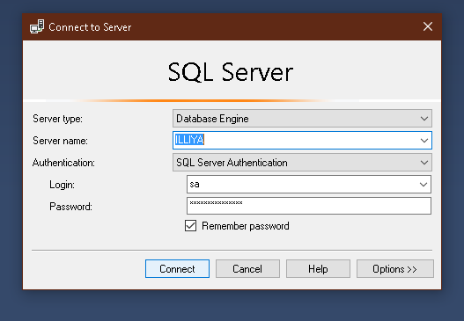

To enable sa login follow this link: <https://docs.microsoft.com/en-us/sql/database-engine/configure-windows/change-server-authentication-mode?view=sql-server-ver15>

3: Import database.sql script file from project folder to SQL server then execute the script.

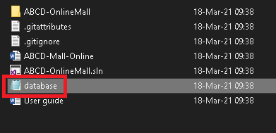

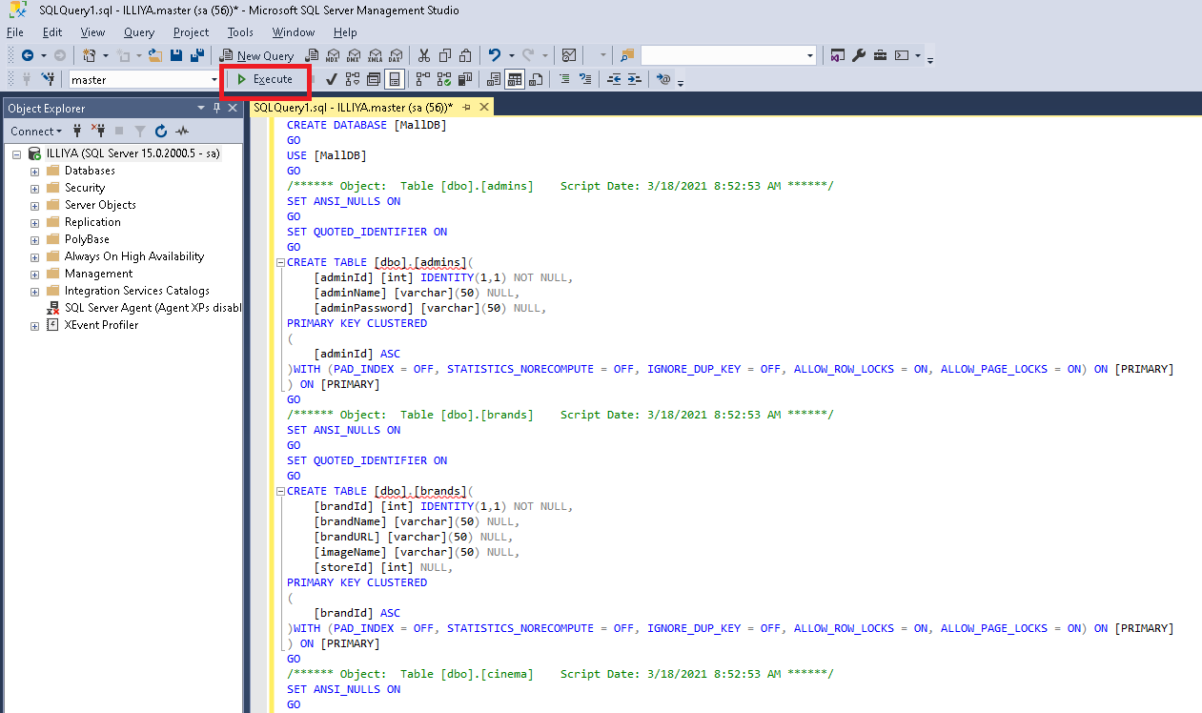

4: Open project in Microsoft Visual Studio 2017(or later version) and run project.

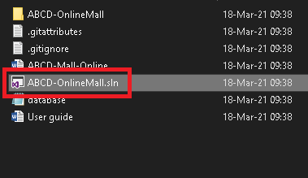

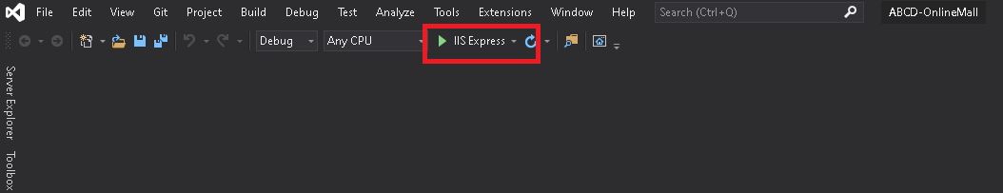

# Admin guide

Click the setting button in homepage and login using this credential:



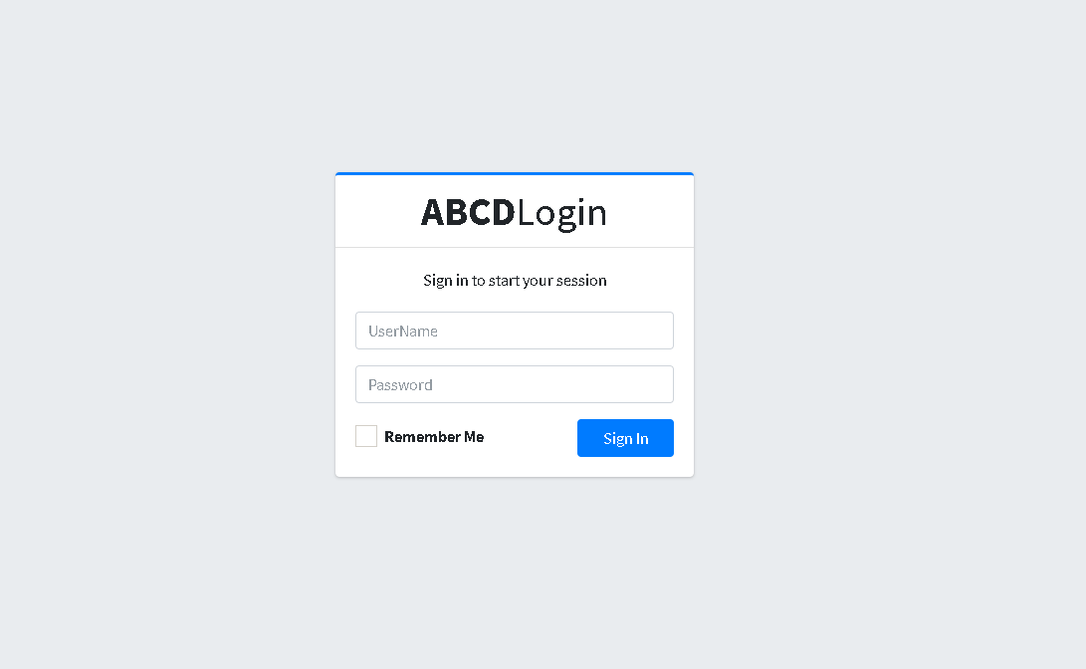  
Username: admin

Password: admin

You will be navigated to Admin view page. 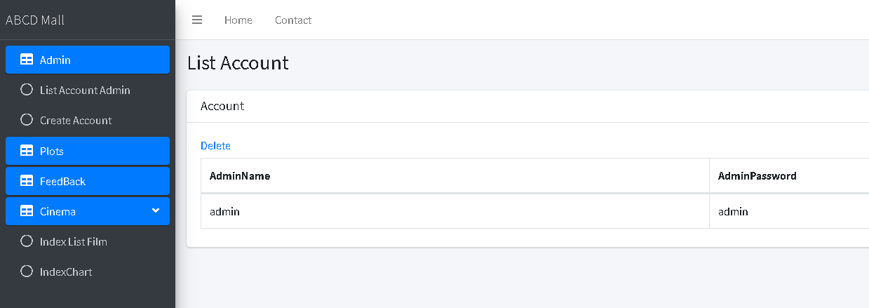

### Mall management

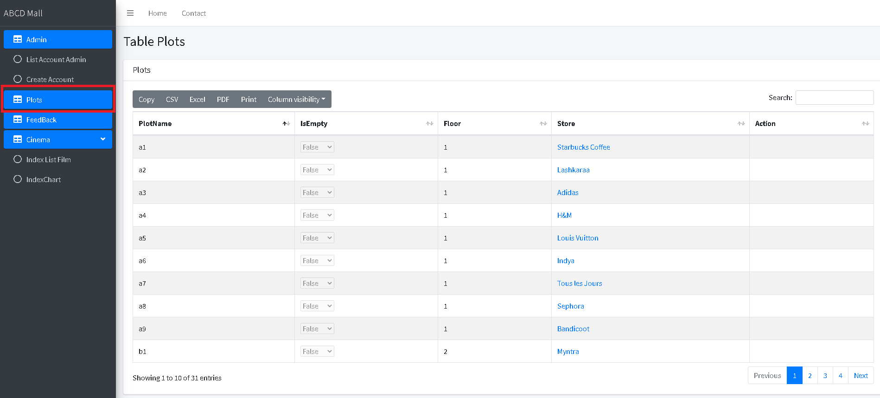To view list of stores click on Plots

To add new store on existing plots click on Add store. **NOTE: You need to have an empty plot to be able to add store into it.**

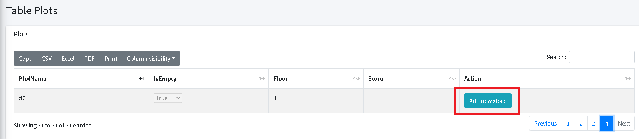

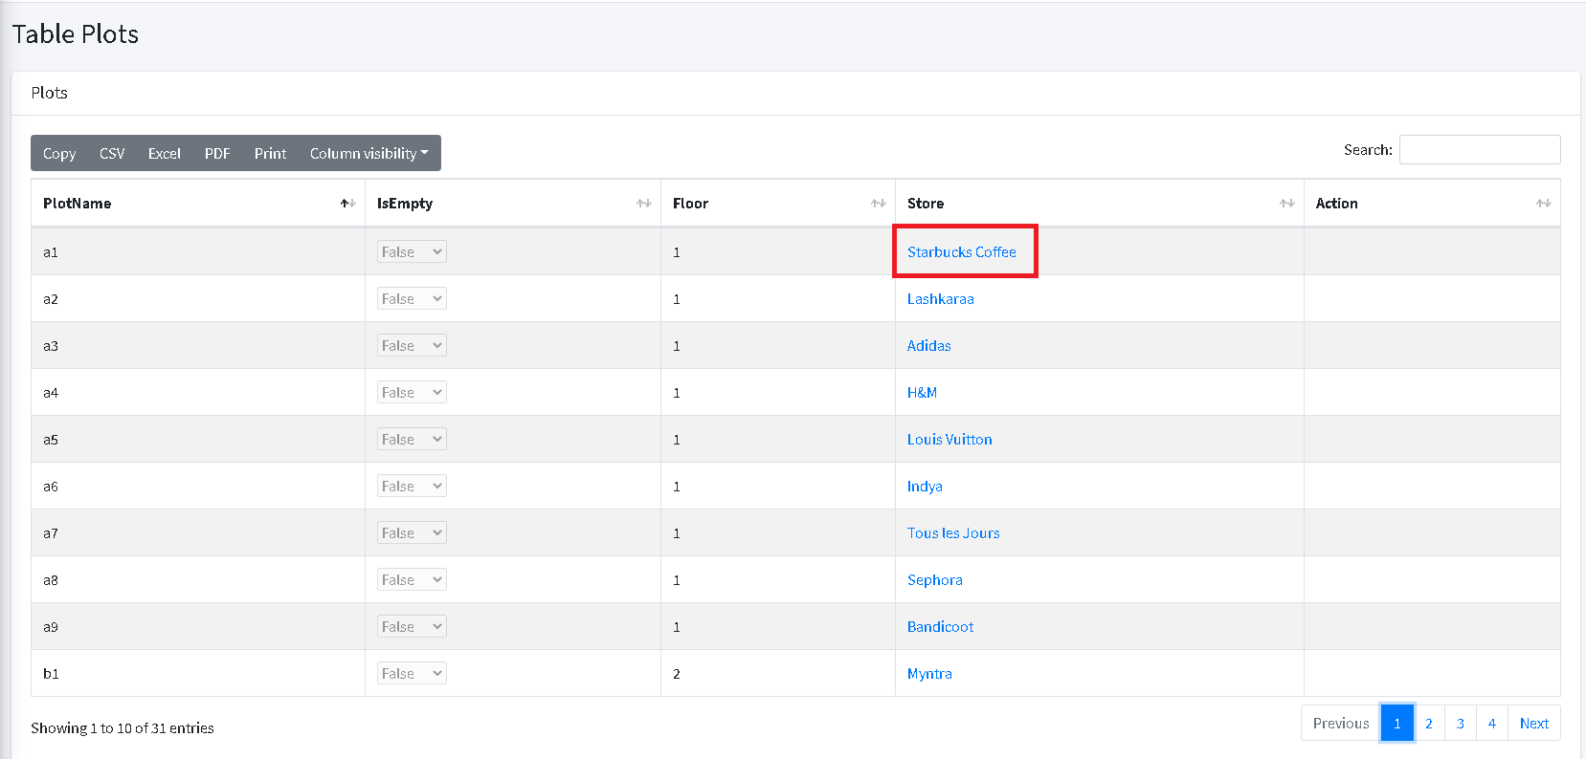To view details of store click on the name of the store:

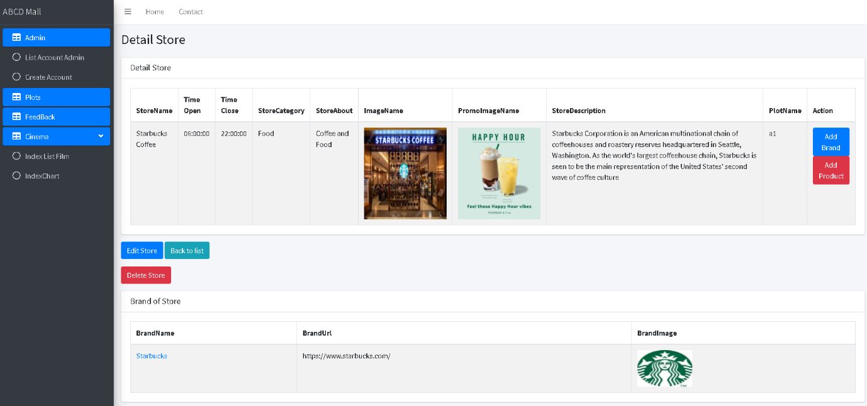You will then redirected to store details page:

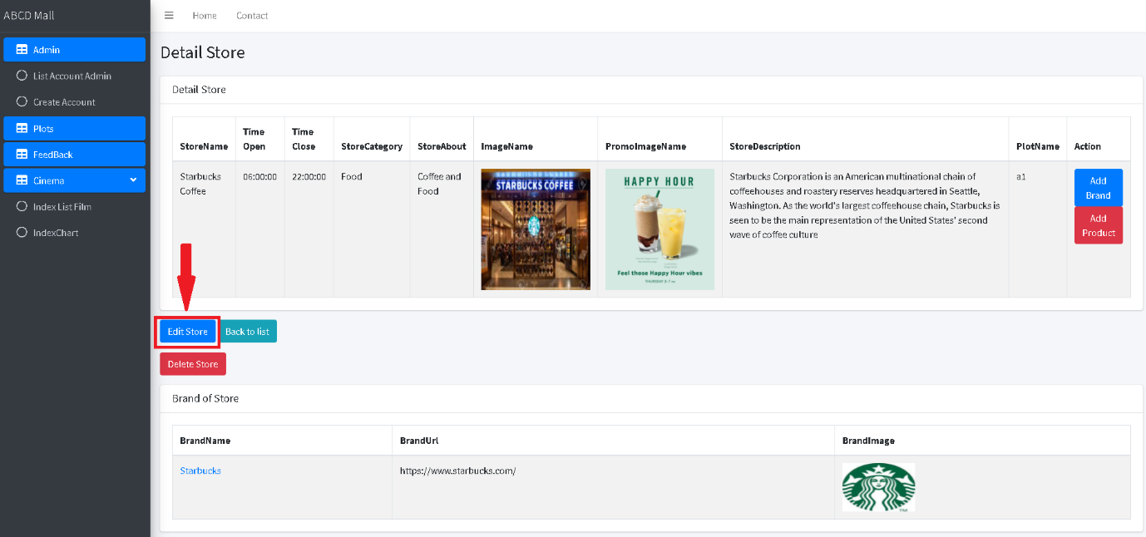To Edit store information click on edit store button

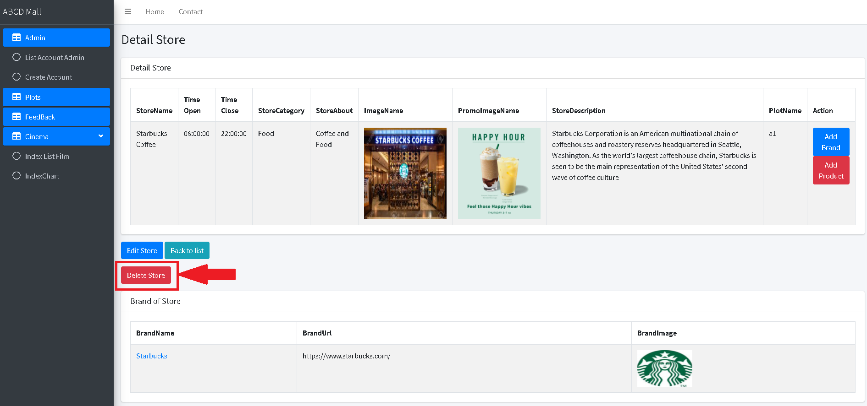To Delete store click on delete store button. **NOTE**: this will also delete brands and products associate with the store

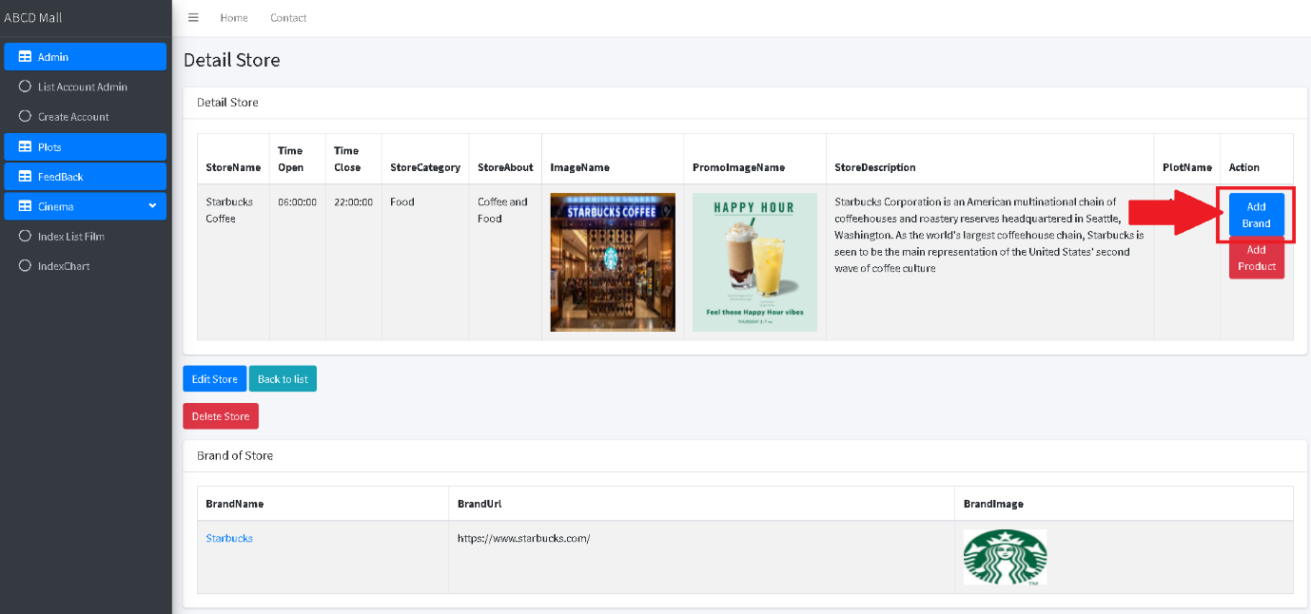To add brands to store click on add brand button in store details page

You will be redirected to Create brand page:

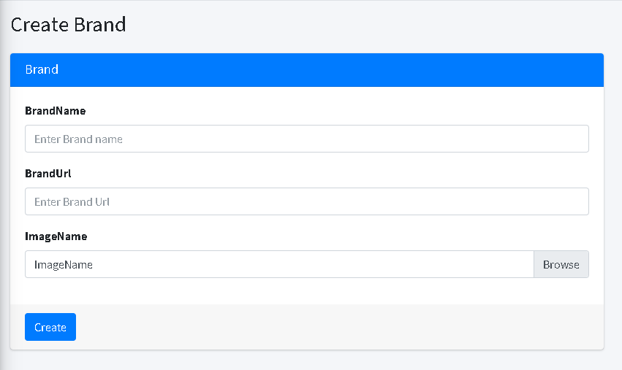

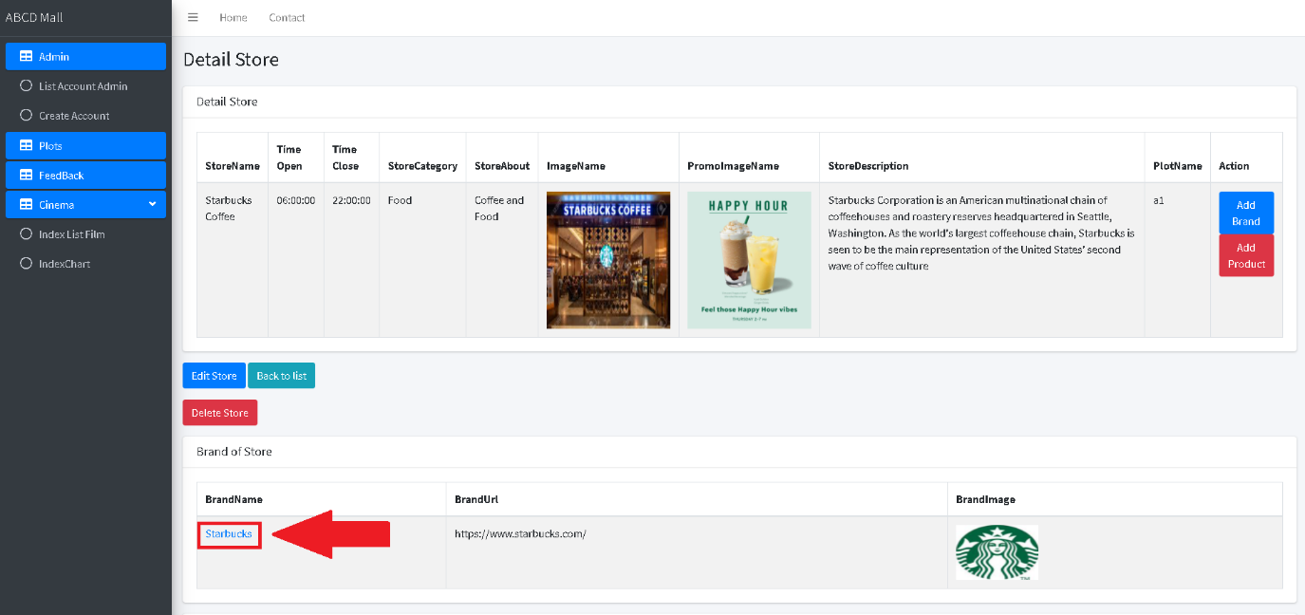To view details of brands click on the name of the brand

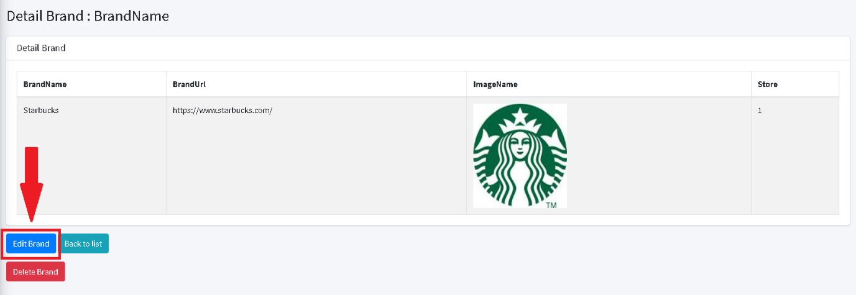To edit details of brands click on the edit button

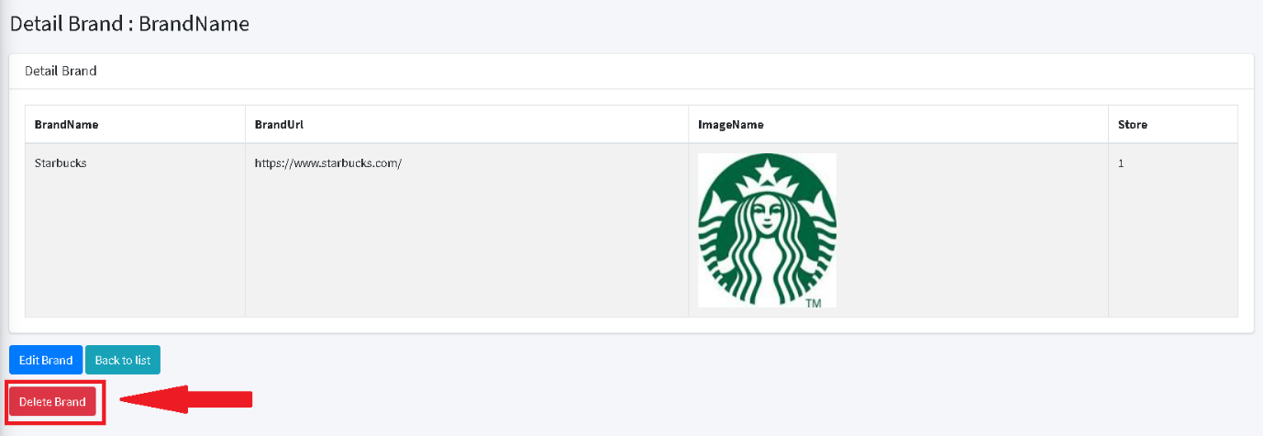To delete brand click on the delete button. **NOTE: This will delete products associate with the brand**

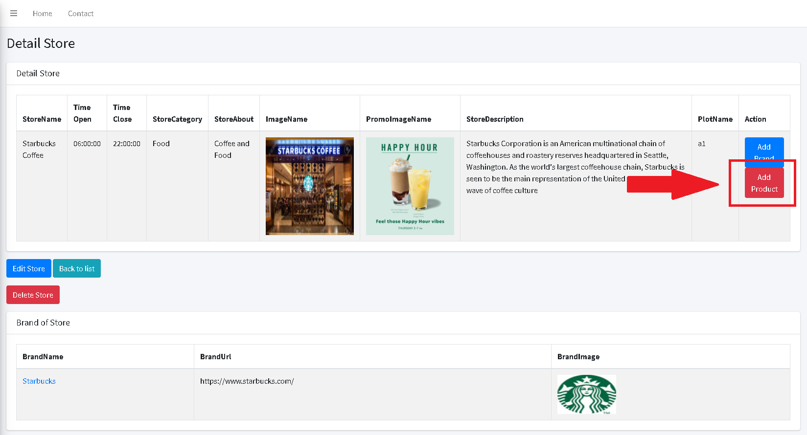To add products to store click on add product button in store details page

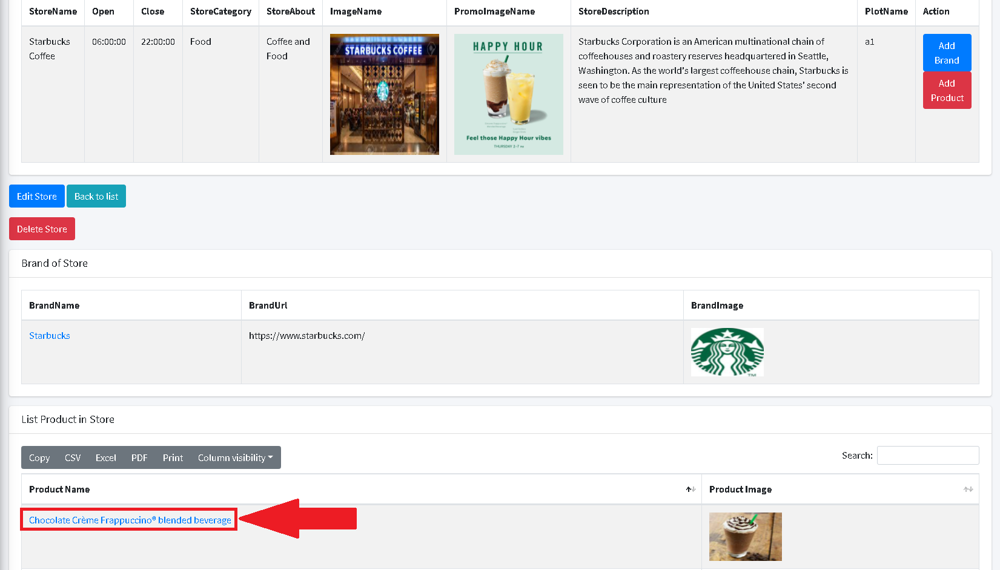To view details of product click on the name of the product

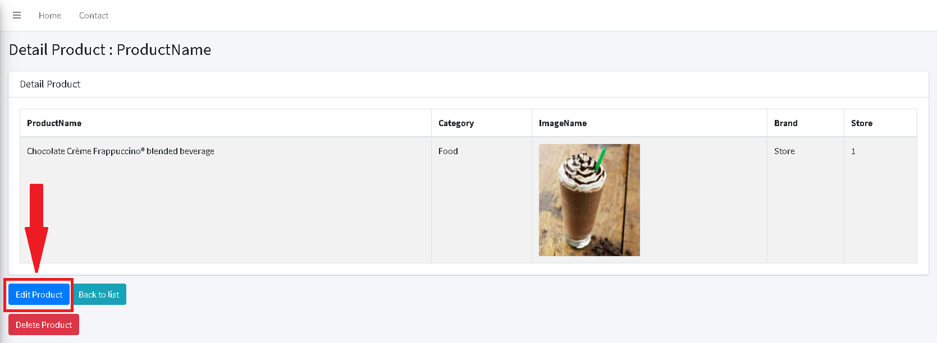To edit details of product click on the edit button

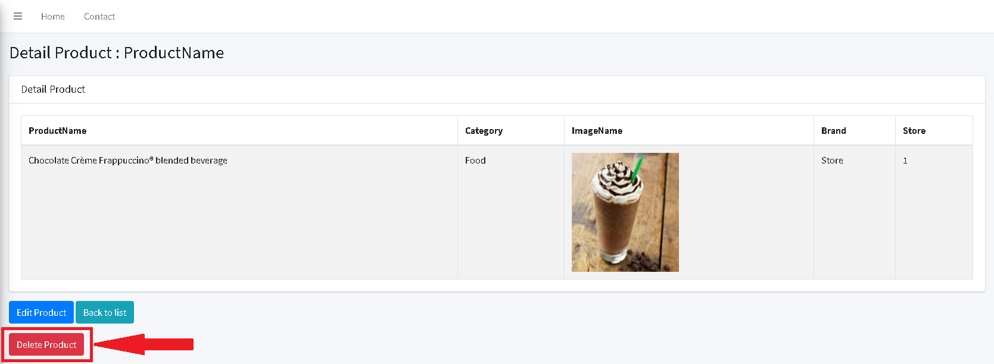To delete details of product click on the delete button

### Movie management

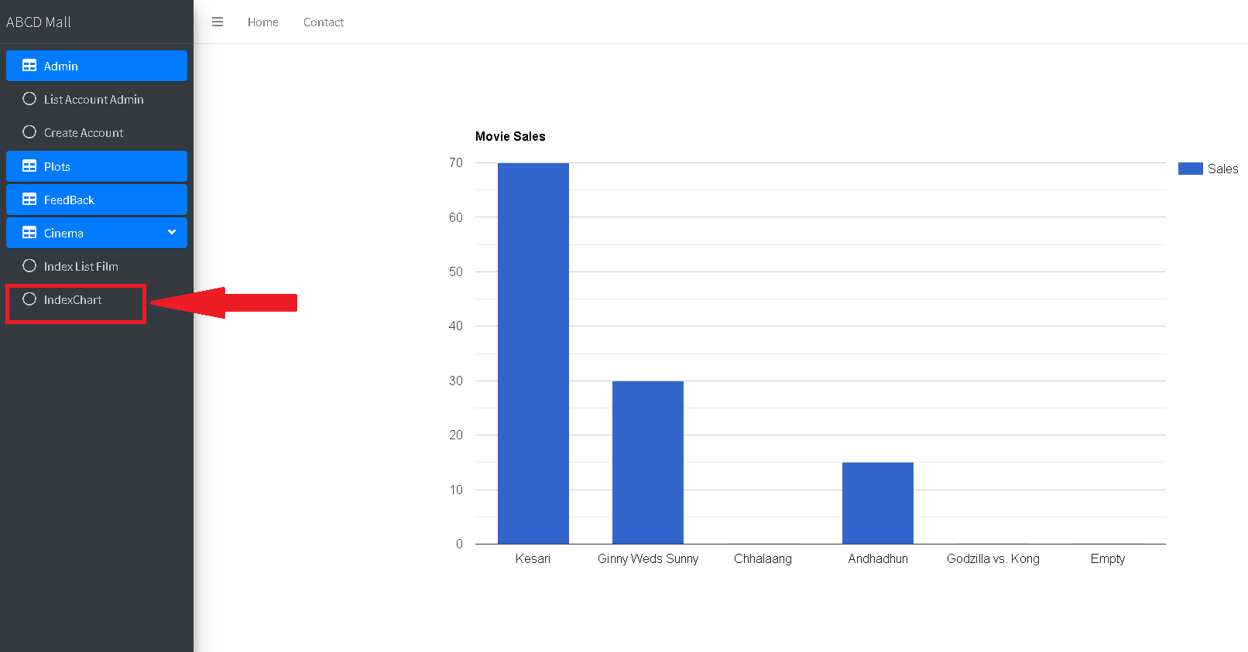To view sales chart of movie click on IndexCharts on the navigation bar

To view list of movies click on Movies

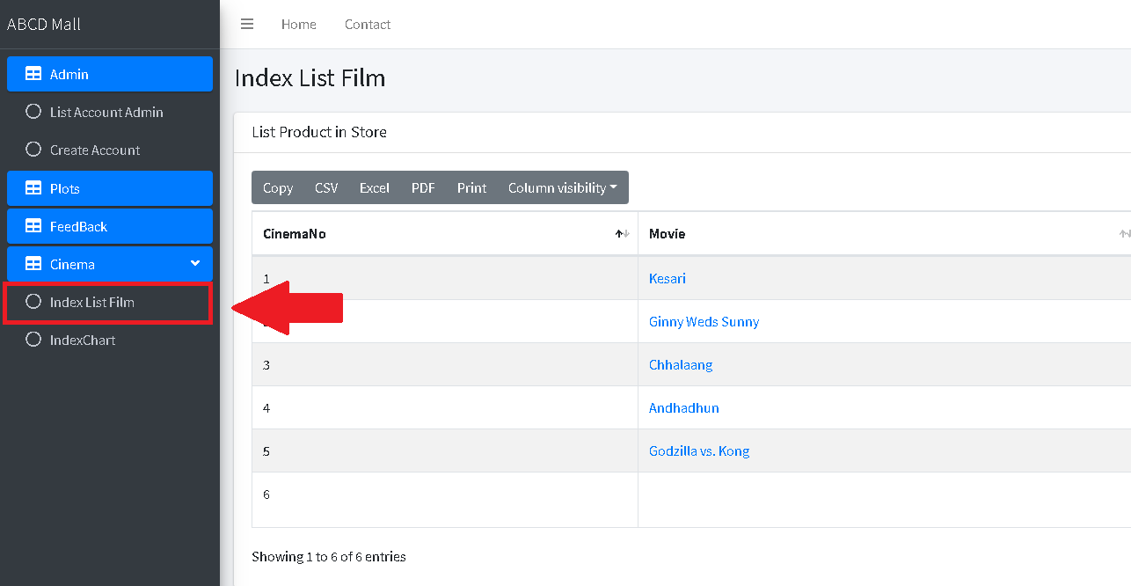

To add new movies to cinema click add movie button

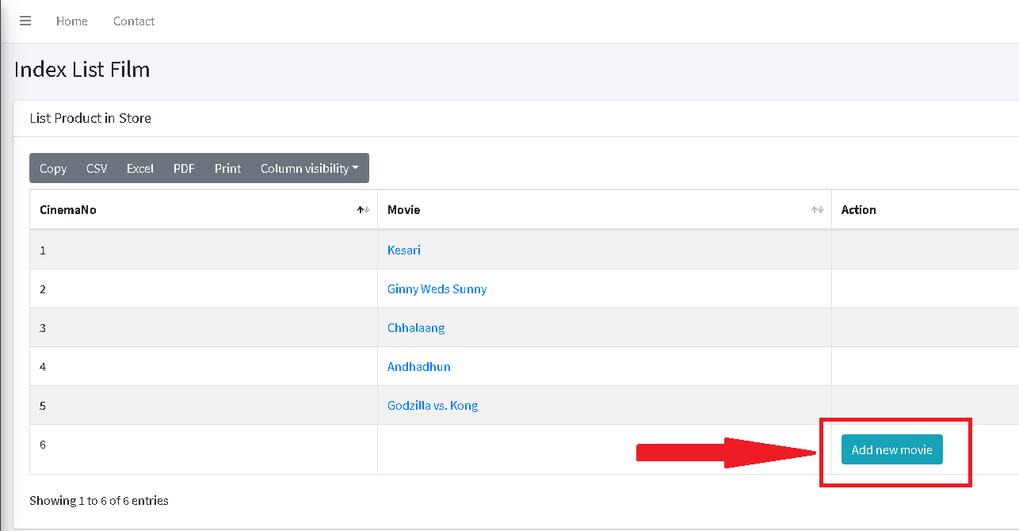

To view details of movie click on movie name, this will redirect you to movie details view

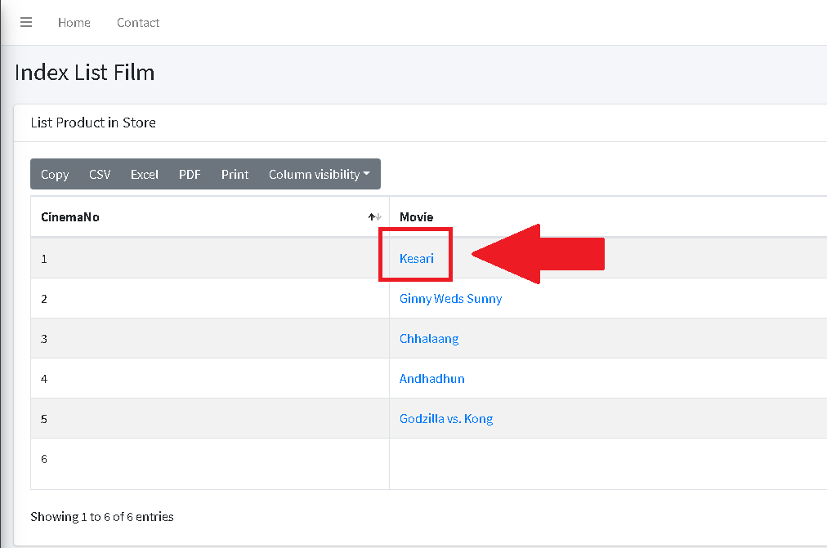

To edit details of movie click on edit button

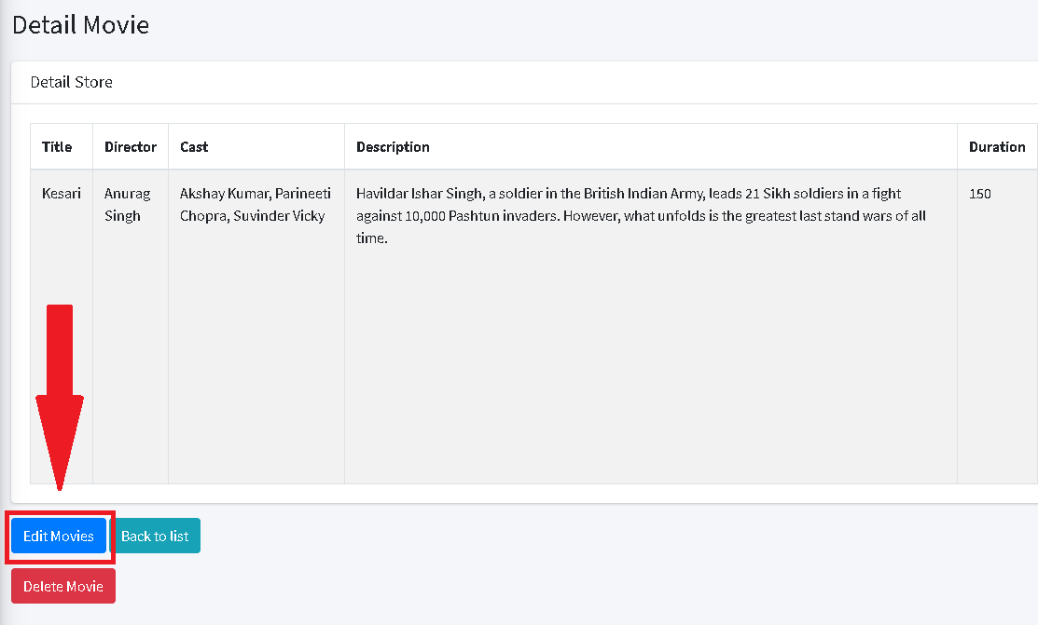

To delete movie click on delete button. **NOTE: this will also delete seat reservation associate with the movie**

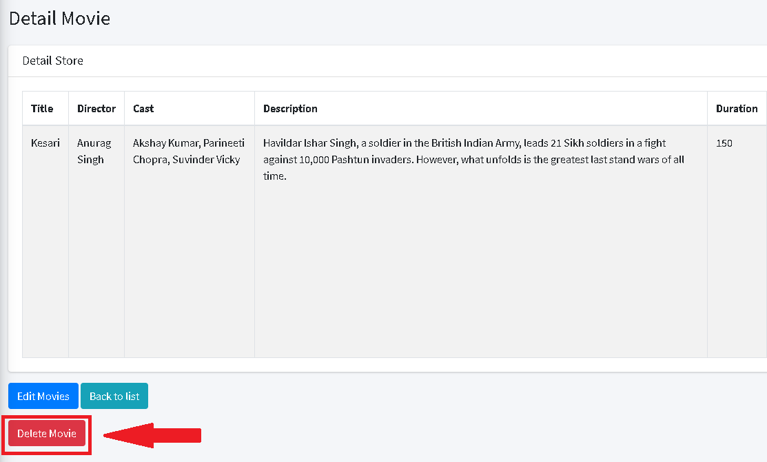

To view list of reservation click on Seat reservation

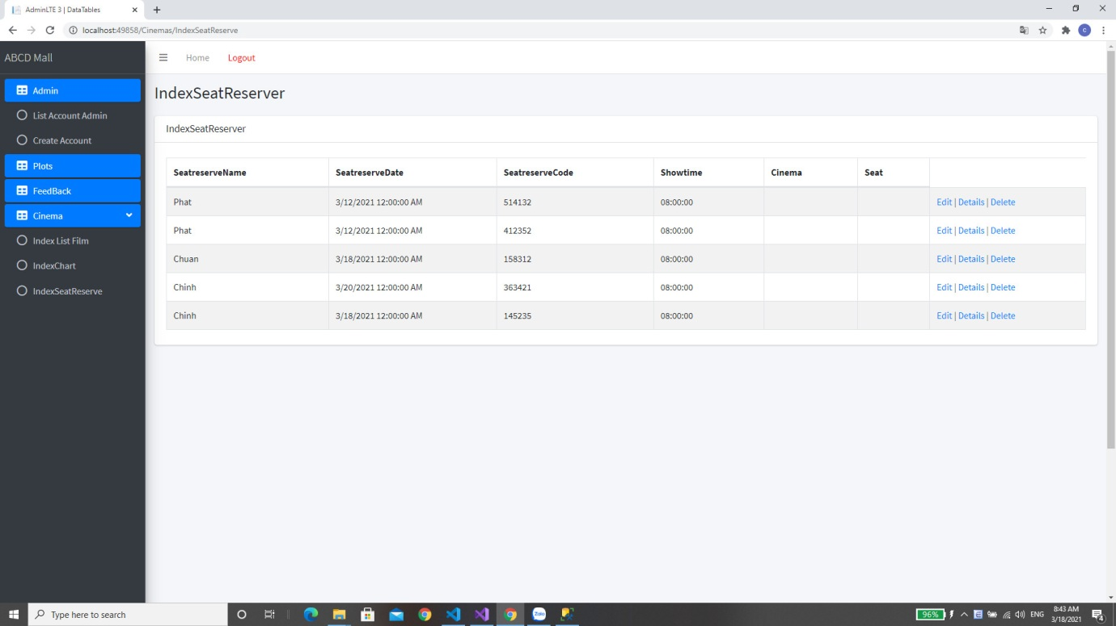

## Feedback management

To view list of feedback click on Feedbacks

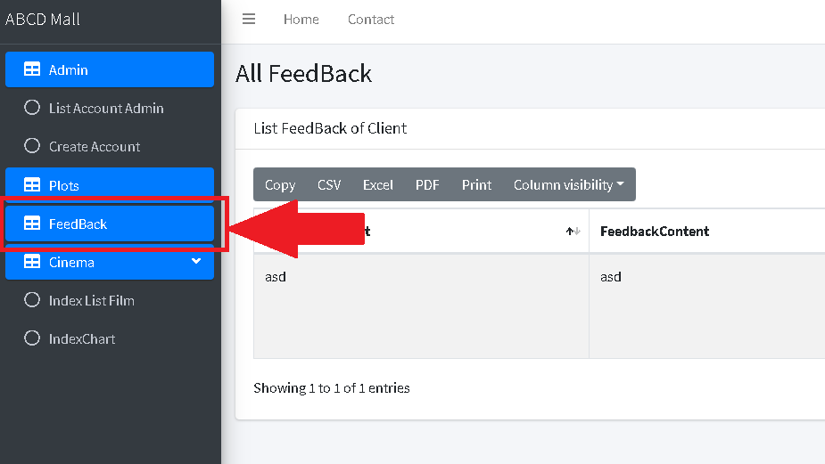

To view details of feedback click on details  
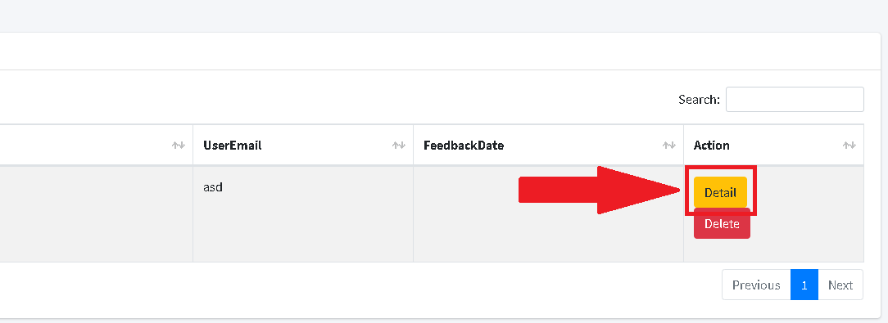

To delete feedback click on delete

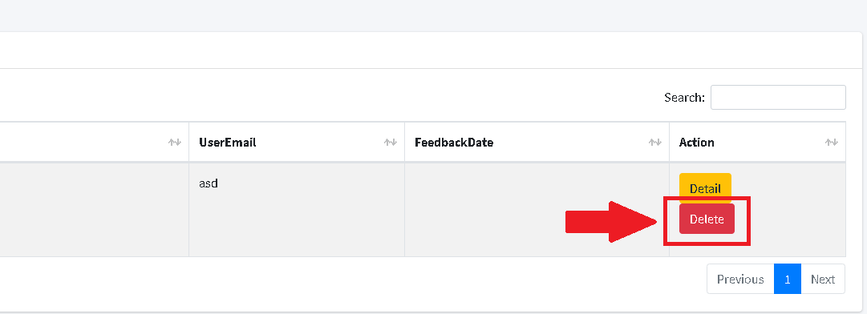

## User management

To view list of user click on List account admin

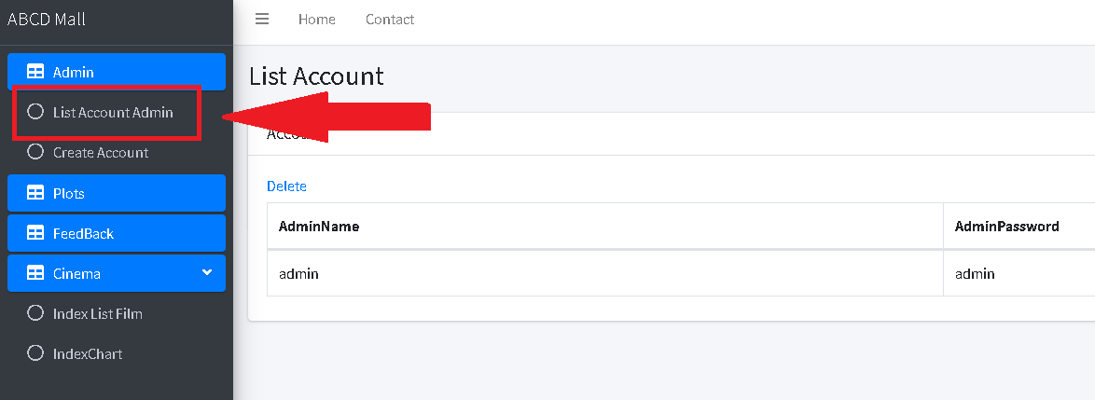

To create new user click on create account button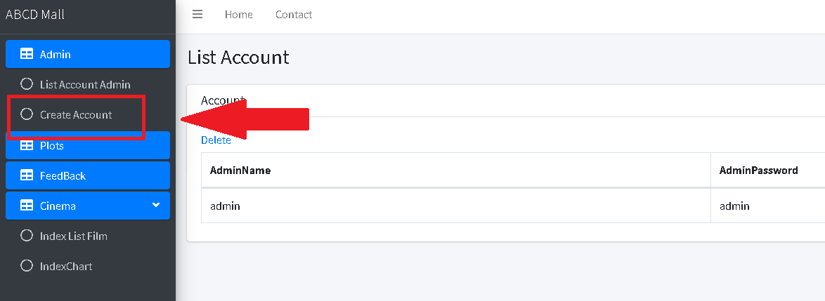

# Client guide

Navigating through the website



## Mall navigation

To view store details click on the store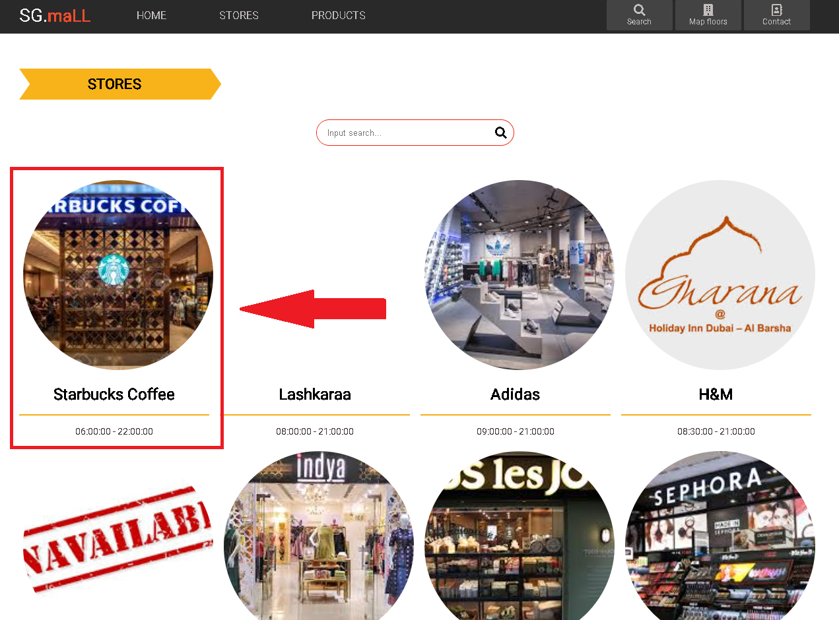This will redirect you to store details page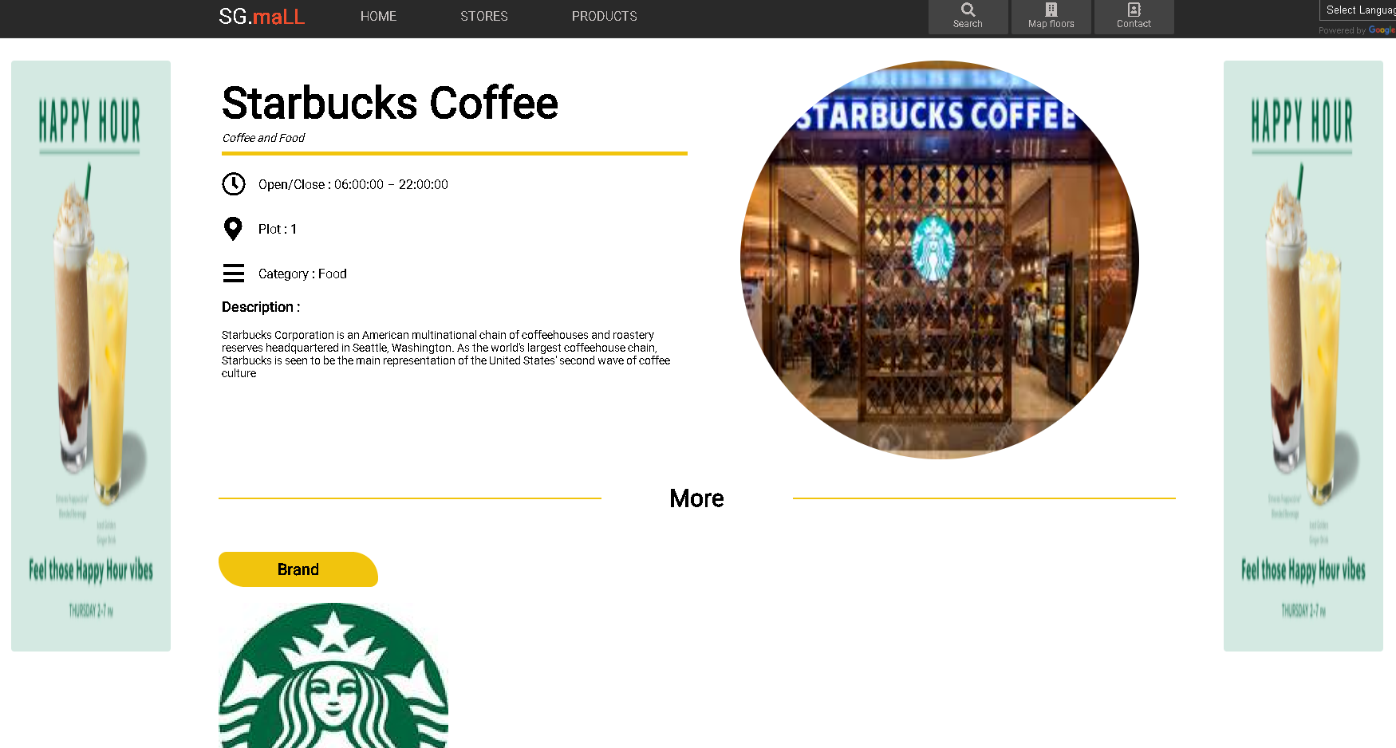

To view product details click on the product in the store details page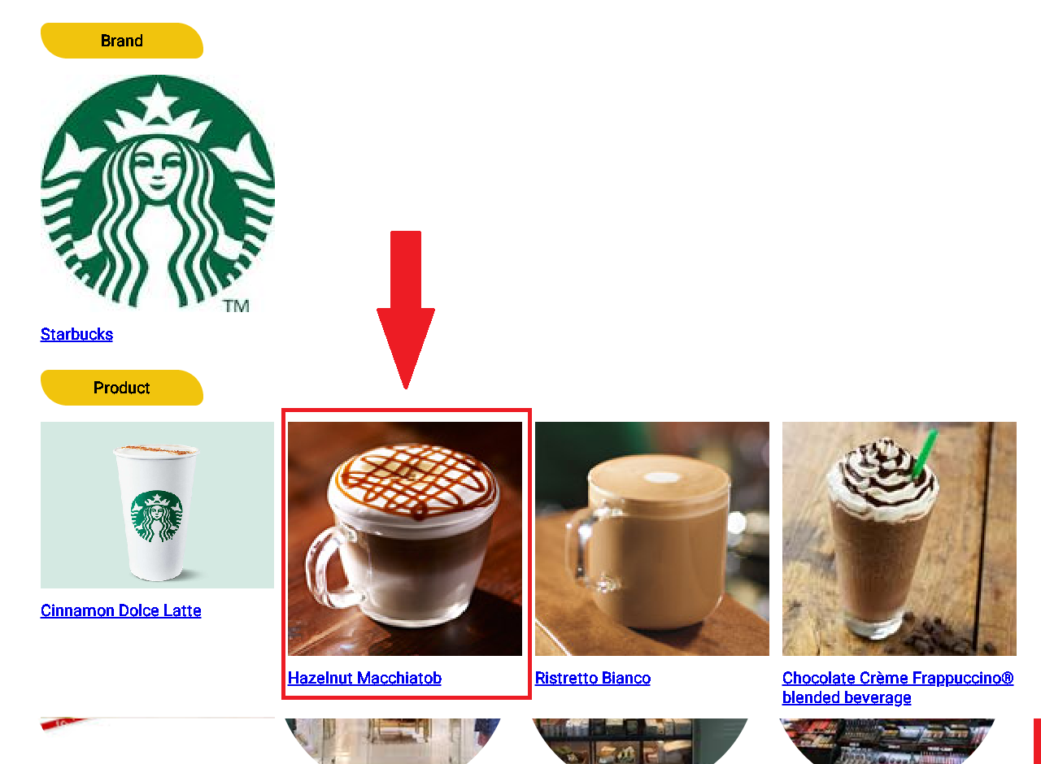

To view brand details click on the brand in the store details page

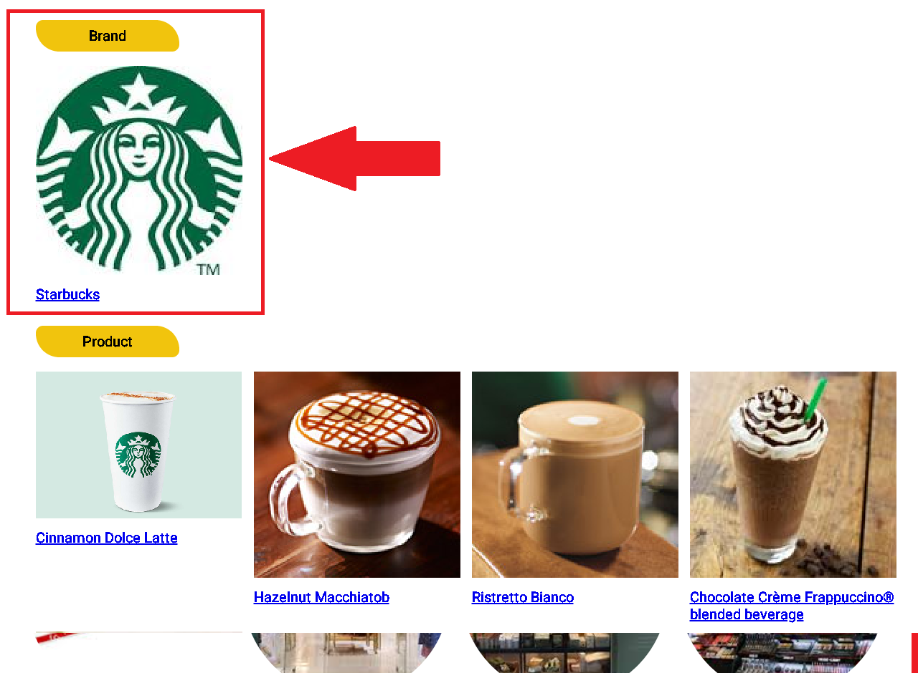

To view list of brands



To view gallery that show list of products click on the product on the navigation bar



You will be redirected to products page, here you can select to filter products according to category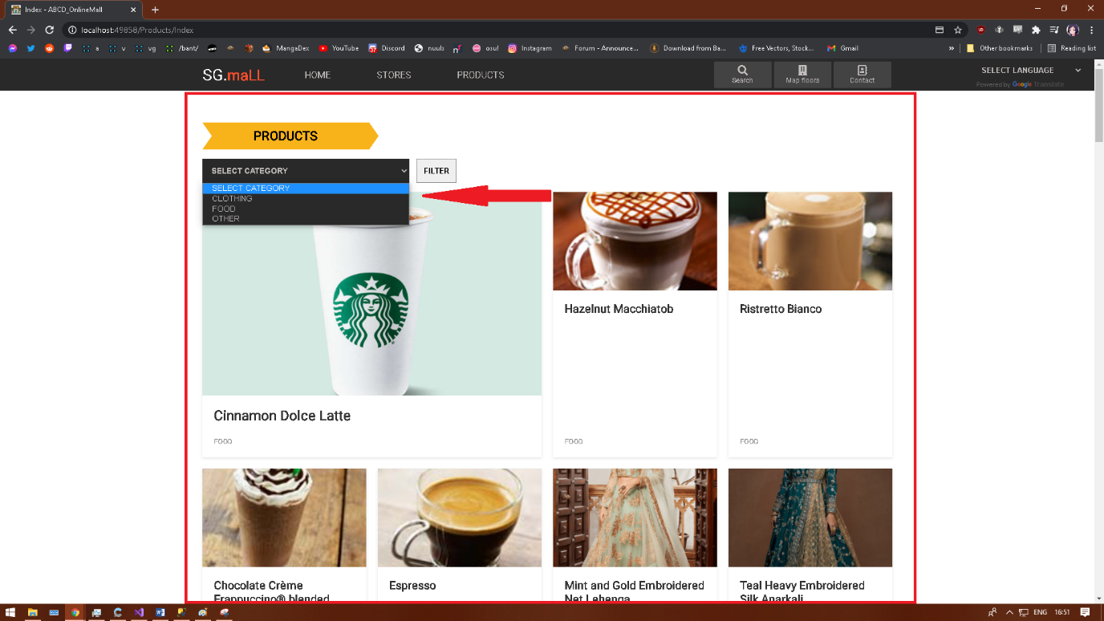

To view contact details click on the contact detail on the navigation bar



To write a feedback click on the feedback tab on the navigation bar



To view mall diagram click on the map floors on the navigation bar



You will be redirected to a 3D interactive Map page where you view stores location

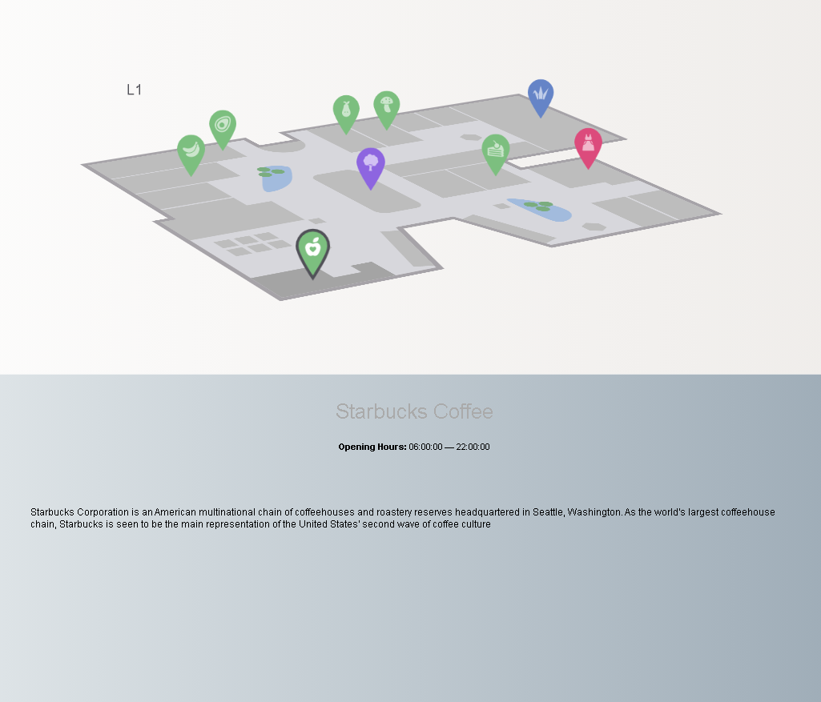

To change language of website click on the google language selector on the navigation bar



## Cinema navigation

To view list of screening movie click on the cinema tab on the navigation bar

To view details of movie click on the movie session

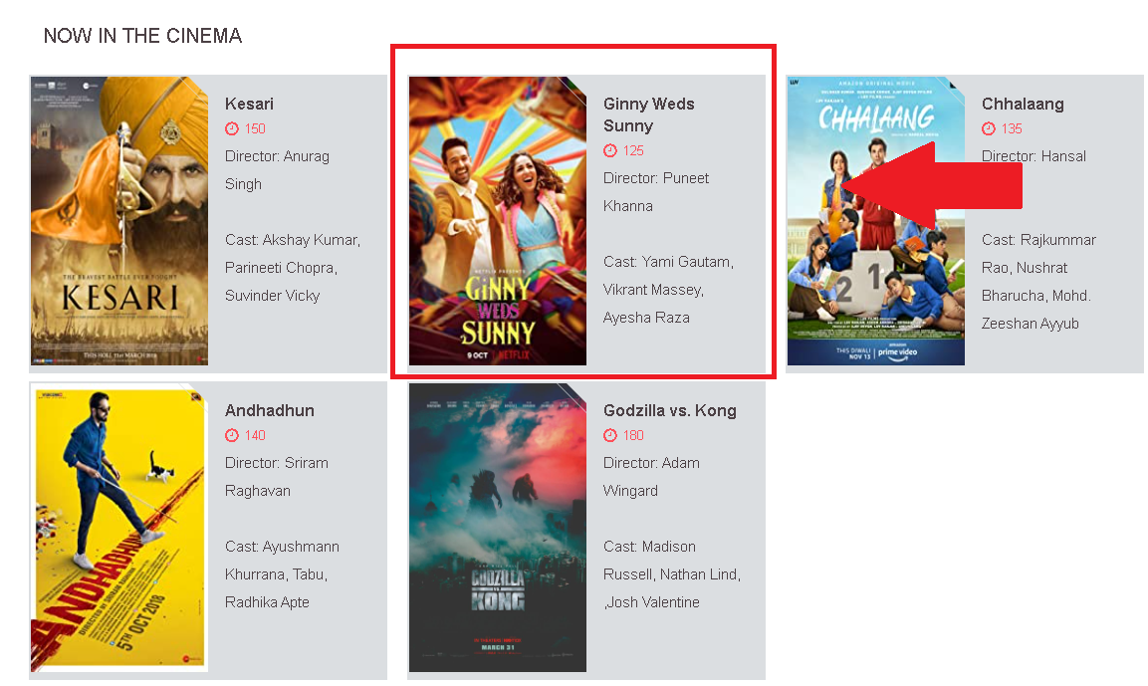

### Movie ticket picking 1: Choose the movie you want to watch



2: Choose date and screening time

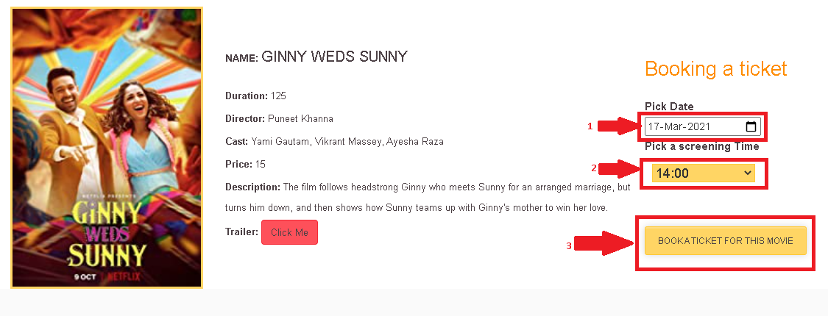

3: Pick seats and enter your Name then process to payment

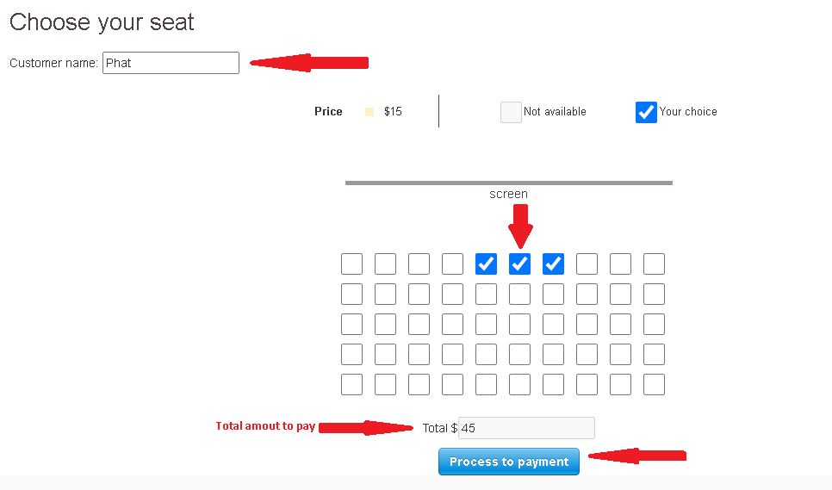

4: Enter credit card information (You can enter the card sample similar to below for testing)

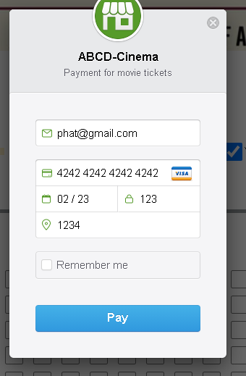

5: Note down ticket details and reservation code, you can save the QR code as image or print the ticket page

